Anti-Lock Braking System

By,

Samarth_2005242

Content:

What is Anti_Lock Braking System? 1

Model Based Design 1

Skills Used in the Model 5

Results 6

References 7

**What is Anti_Lock Braking System?**

Anti-Locking Braking system (ABS) is a safety anti-skid braking system used on aircraft and on land vehicles, such as cars, motorcycles, trucks, and buses. ABS Operates by preventing the wheels from locking up during braking, thereby maintaining tractive contact with the road surface and allowing the driver to maintain more control over the vehicle.

**Model Based Design**

By using Reference Videos from YouTube and Google, I build a Anti-Lock Braking System model in Matlab/Simulink Which could give the Final output of the Wheel Speed being Decelerating.

The Reference Formulae are as follow,

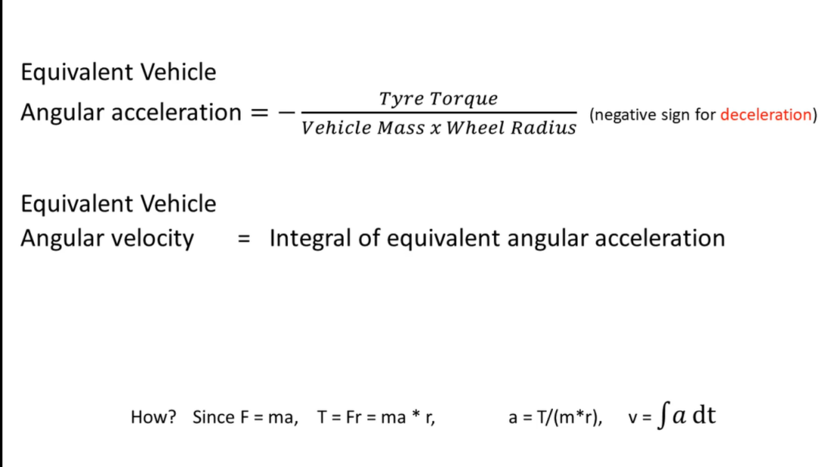

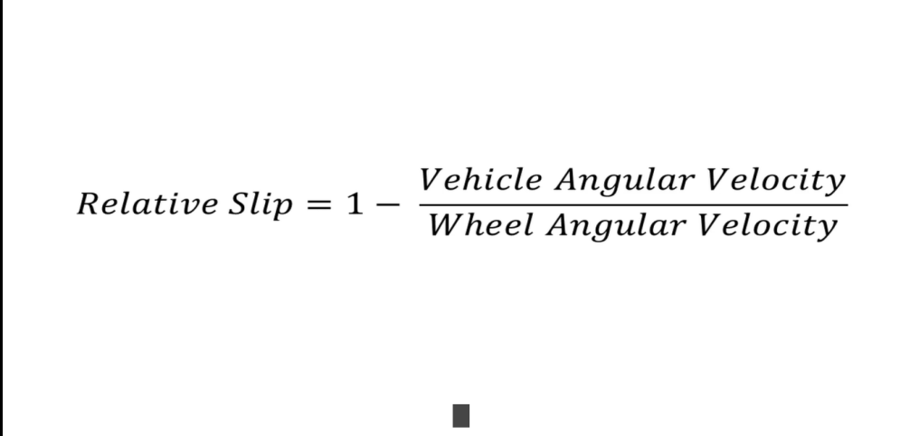

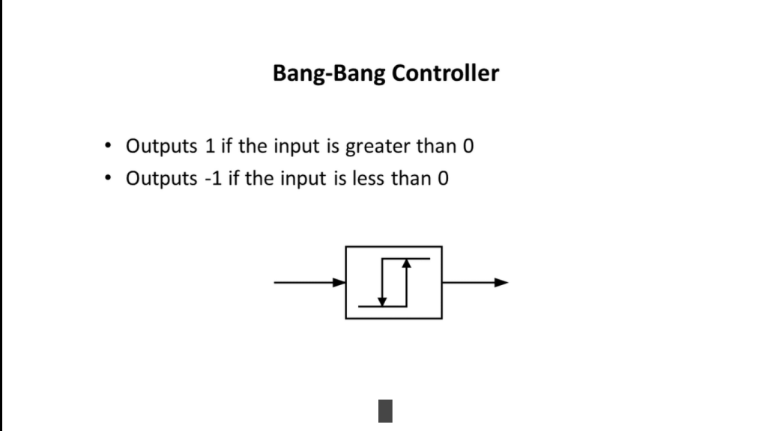

**Skills Used in the Model**

**Callbacks:**

Callback is used to Send the Variables from Matlab Script to the Simulink Model.

**Data Inspector:**

Data Inspector is used to Log all the Output Signals that is Vehicle speed, Wheel Speed, Vehicle angular speed, Stopping distance and show the Output graph.

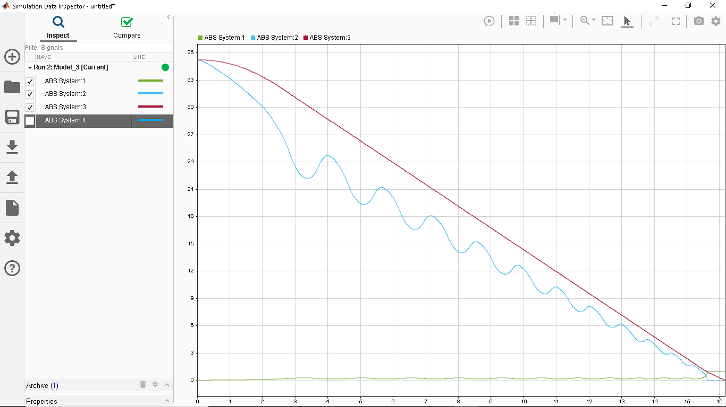

**Solver Selection Strategy:**

Solver Strategy used is ODE113.

**Matlab Function Blocks:**

Matlab Function Blocks can be used in alternative to the Slip Calculation function/Subsystem in simulink.

**Look-up Table:**

Look-up Table is created to get the values for Coefficient of Friction **vs** Slip. The Values are added into the 1D Look-up Table.

**Signal Builder:**

The Input for the Model is given through a Signal builder which gives the value for the Desired slip.

**Results**:

Here are Some Snapshot of the Resulting Output of the Model.

*Wheel Speed:*

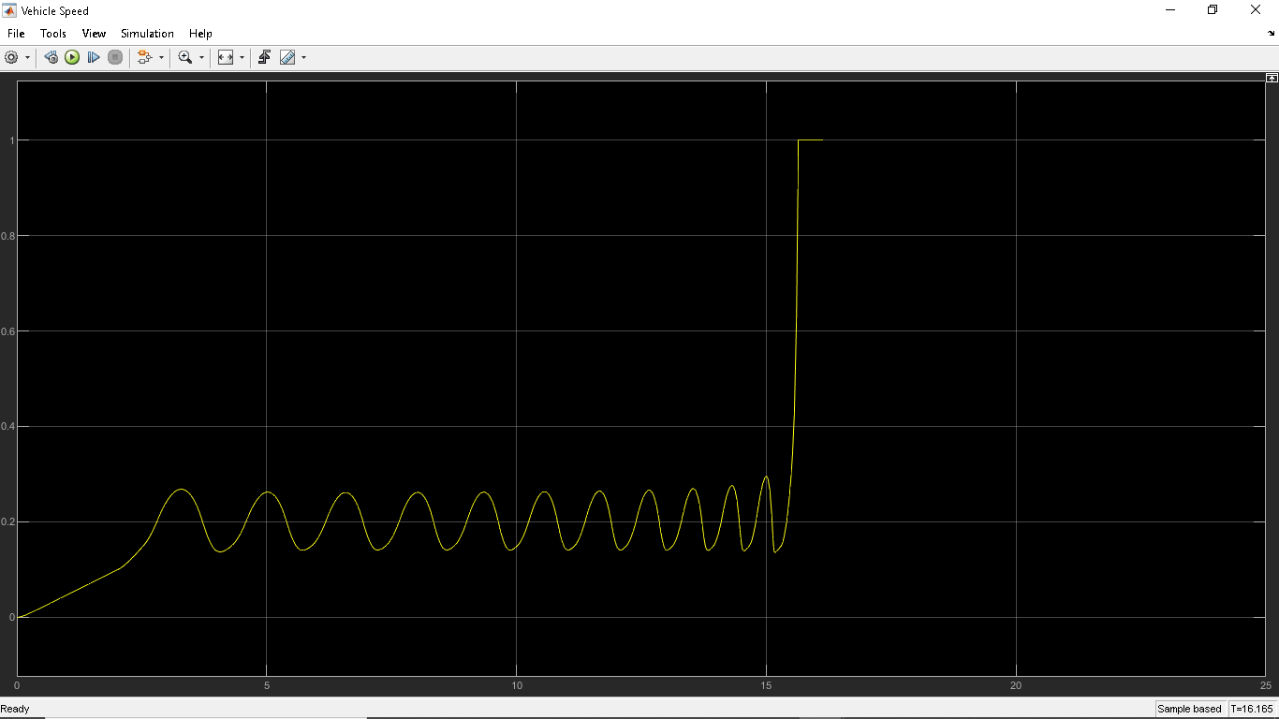

*Vehicle Angular Speed:*

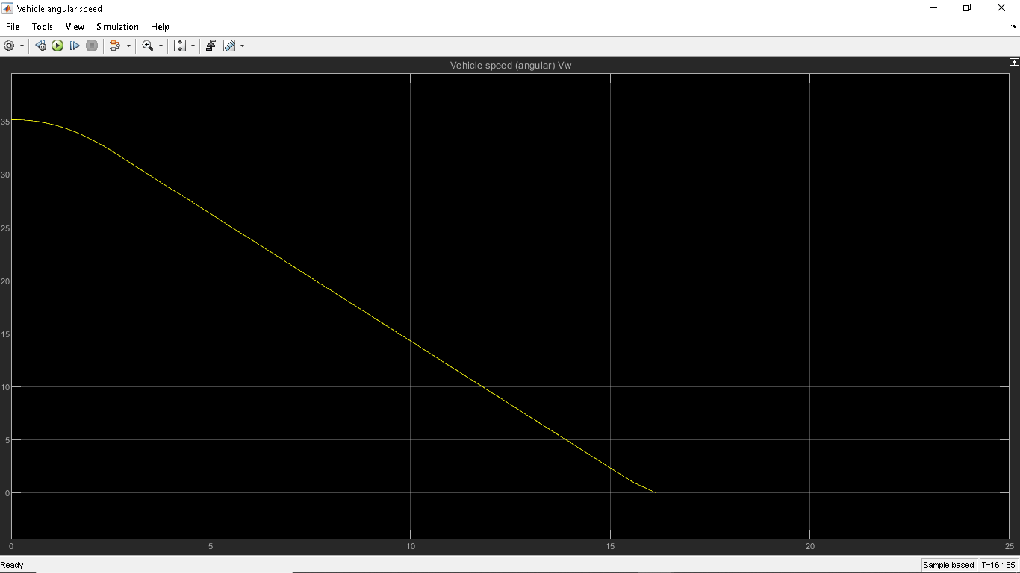

*Wheel Speed:*

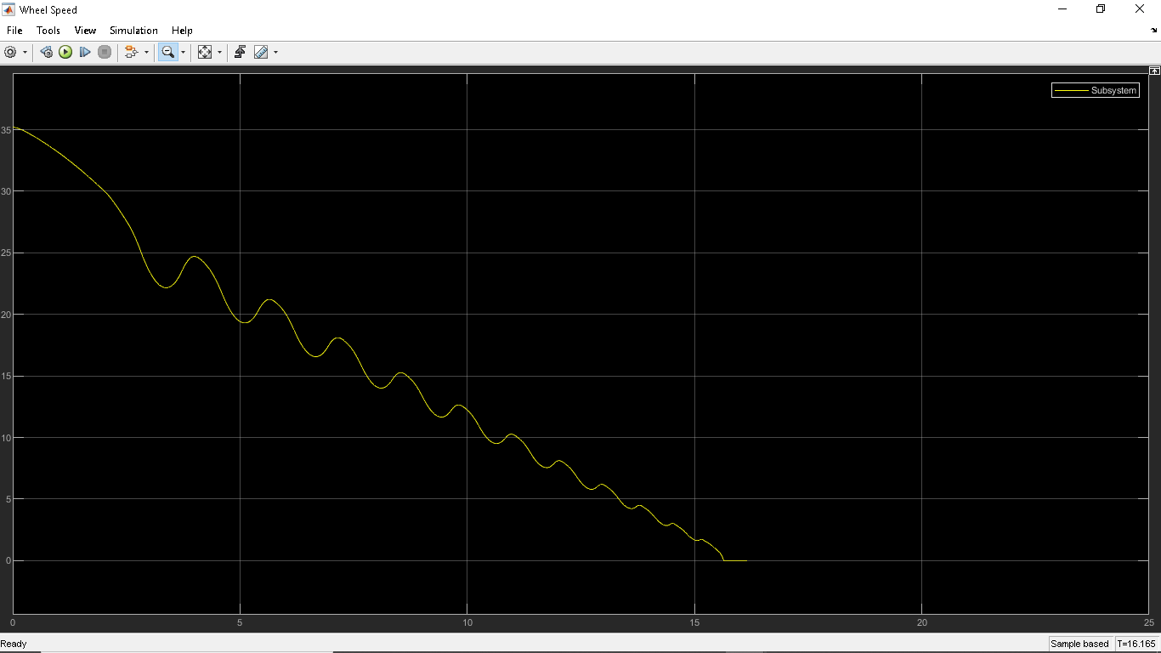

*Stopping Distance:*

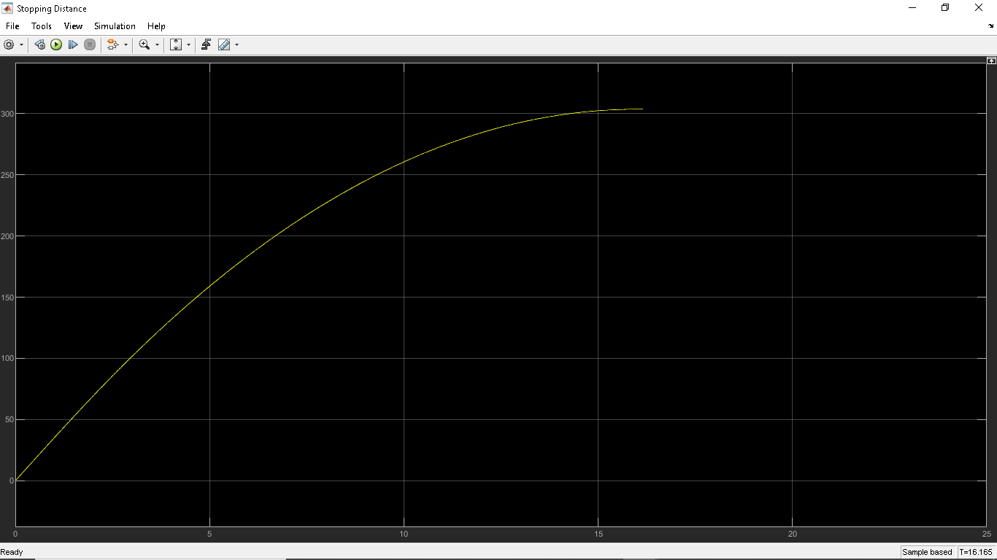

**References**:

<https://www.youtube.com/watch?v=G8VbGtLOmR8&list=LL&index=1>

<https://in.mathworks.com/help/simulink/callback-functions.html>

<https://en.wikipedia.org/wiki/Anti-lock_braking_system>

<https://in.mathworks.com/help/matlab/math/choose-an-ode-solver.html>

<https://in.mathworks.com/help/simulink/what-is-a-matlab-function-block.html>